**Project Design phase-II**

**Technology Stack (Architecture Stack)**

|  |  |
| --- | --- |
| Date | 21-10-2022 |
| Team ID | PNT2022TMID38223 |
| Project Name | Fertilizers Recommendation System for Disease Prediction |
| Maximum Marks | 4mark |

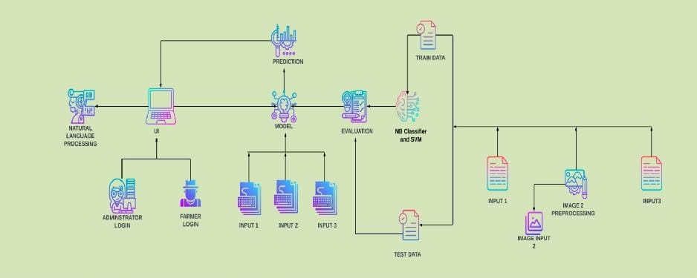

**Table-1:Component &Technologies**

|  |  |  |  |
| --- | --- | --- | --- |
| **S.NO** | **Component** | **Description** | **Technology** |
| 1. | User Interface | How the user interacts with the application .To depict the human-computer interaction and communication. | HTML,CSS,JS |
| 2. | Application Logic-1 | A page to upload images as input | Python |
| 3. | Application Logic-2 | To use the Machine  Learning model and predicting the result | Python |
| 4. | Database | Structured data-images | MySQL |
| 5. | Cloud Database | Database that typically runs on a cloud computing platform and access to the database is provided as-a- service | IBM Cloud Databases for MySQL |
| 6. | File Storage | To store data in a hierachicalstructure | Local File system |
| 7. | Machine Learning Model | Here, we use a Support Vector Machine Algorithm that is used widely in Classification and Regression problems. | Random Forest,XG Boost |
| 8. | External API-1 | Purpose of External API used in the application | IBM Weather API, etc. |
| 9. | External API-2 | Purpose of External API used in the application | Aadhar API, etc. |
| 10. | Infrastructure (Server/cloud) | Application Deployment on Local System /Cloud  Local Server Configuration:  Cloud Server Configuration: | Local, CloudFoundry, Kubernetes, etc. |

**Table-2: Application Characteristics**

|  |  |  |  |
| --- | --- | --- | --- |
| **S.NO** | **Characteristics** | **Description** | **Technology** |
| 1. | Open-Source Frameworks | Flask micro web framework | Written in python. It is classified as a micro frame work because it does not require particular tools or libraries. It has no database abstraction layers, form validation, or any other components where preexisting third-party libraries provide common function |
| 2. | Security Implementations | With all aspects of the job, including detecting malicious attacks, analyzing the network, endpoint protection and vulnerability assessment, Sign in encryption | IBM Cloud App ID Services |
| 3. | Availability | Available for all data size | - |
| 4. | Performance | Can extend the storage according to our needs | Python, Angular JS |